***EQUIFAX***

CMS Fusion

**Output Process**

**DOCUMENTATION**

Table of Contents

Output Tab 2

1. Output Setup 3

Process Name 4

Select Output Tables 4

File Layout 4

Name the Output Table 4

2. Record Types 4

Split Records 5

3. Output Alias 5

4. Output Configuration 6

Seeding 7

Define Layout 7

Build the Actual Layout 7

Configure Alias 8

5. Output Move Statement 9

6. Sort Order 11

7. Output File Naming / Output File Splitting 11

Split the File? 11

Limit Output Count? 12

8. Data Check 13

9. Summary 13

# Output Tab

This tab is used to create an output files. That means it is used to create a process to take the data that are in greenplum, and write it to a file.

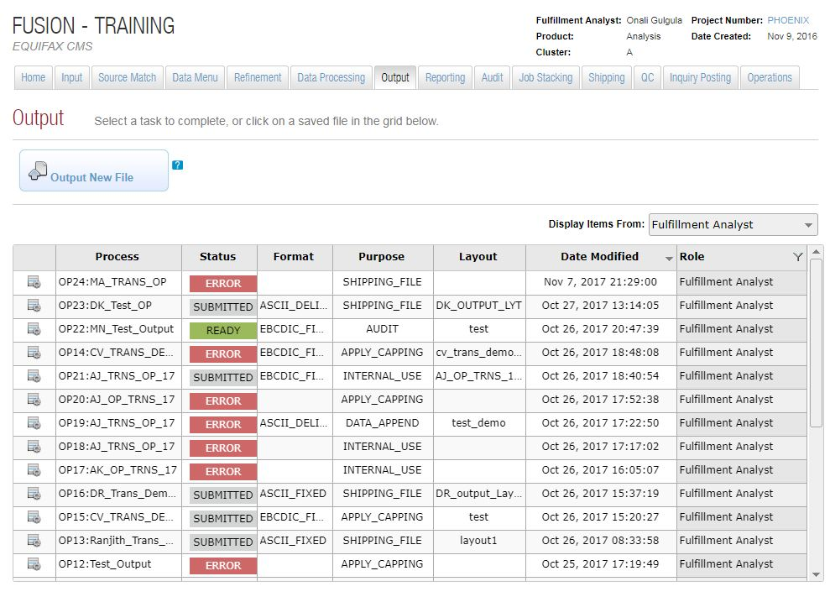

Output page will lists all the existing output process including its details.

* **Process** – Displays the name of the output process.
* **Status** – Displays the current status of the process. It can be either Ready, Submitted or Error.
* **Format** – Displays the format of the output file.
* **Purpose** – Displays the purpose of the output file. Eg: Shipping, Audit.
* **Layout** – Displays the layout which is used to create the output file.
* **Date Modified** – Displays the last date that the process was modified.
* **Role** – Displays the role of the user who created the output process.

We can perform the following operations on an existing output process:

* **Edit** – Possible only if the process is in error or ready status. Once the process is submitted we cannot edit that process.
* **Duplicate**
* **View Summary**

We can create a new output process by clicking on the Output New File button. This will take the user to the Output Setup Page.

## Output Setup

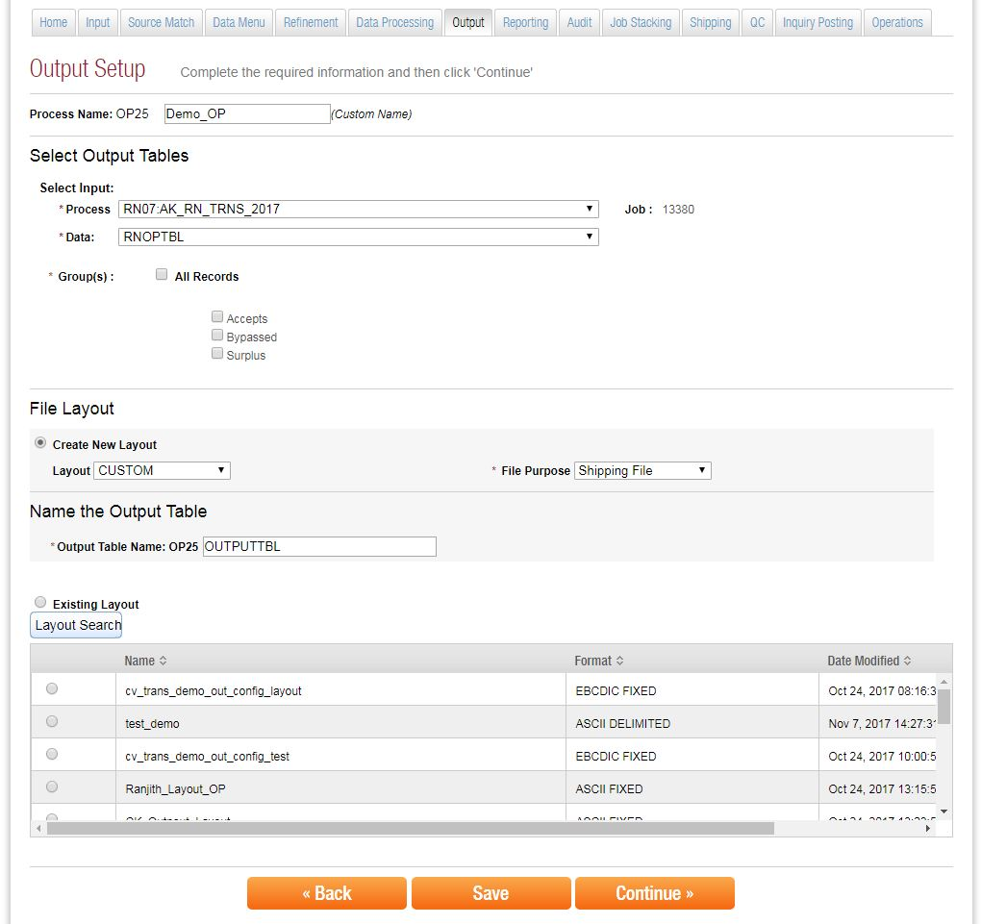

Here the user needs to enter the following information.

## Process Name

This will allow the user to give a name for the output process. The Process name is divided into two parts. The first part of the process name is assigned by the system and the second part is entered by the user. This is mechanism is used to avoid the naming conflicts.

## Select Output Tables

Here the user needs to select the input process for the Output Process. This can be any of the existing process.

**Groups:**

This option will be enabled only for some certain type of inputs. It contains following options:

* **All Records** – Includes all the records
* **Accepts** – This includes all the records which meet the acceptance criteria. That means all the processed records.
* **Bypassed** – This includes all the records that are not processed.
* **Surplus** – This includes all the records that are not accepted.

If we have a total of 10000 records and we processed 3000 records from it. Then the non-processed 7000 records form the **Bypassed** record set. If we need only 1000 records from the processed 3000 records then these 1000 records forms the **Accepts** Record set remaining record are treated as **Surplus** records.

## File Layout

This section defines how the Output File will be formatted. This allows the user to select a layout for the output file. Different options are:

* **Create New Layout** – This will allow the user to create a new layout for the output file. Here the user needs to specify the purpose of the file. This can be either Shipping, Audit, Internal Use, Data Append, Apply Capping or Other. Commonly used options are Shipping and Apply Capping.
* **Existing Layout** – This will enables the user to select an existing layout for output creation. Layout search will allow the user to select the layouts from other projects.

## Name the Output Table

This will allow the user to give a name for the output table.

## Record Types

This section specifies how we need to group the records that are going to write into a file.

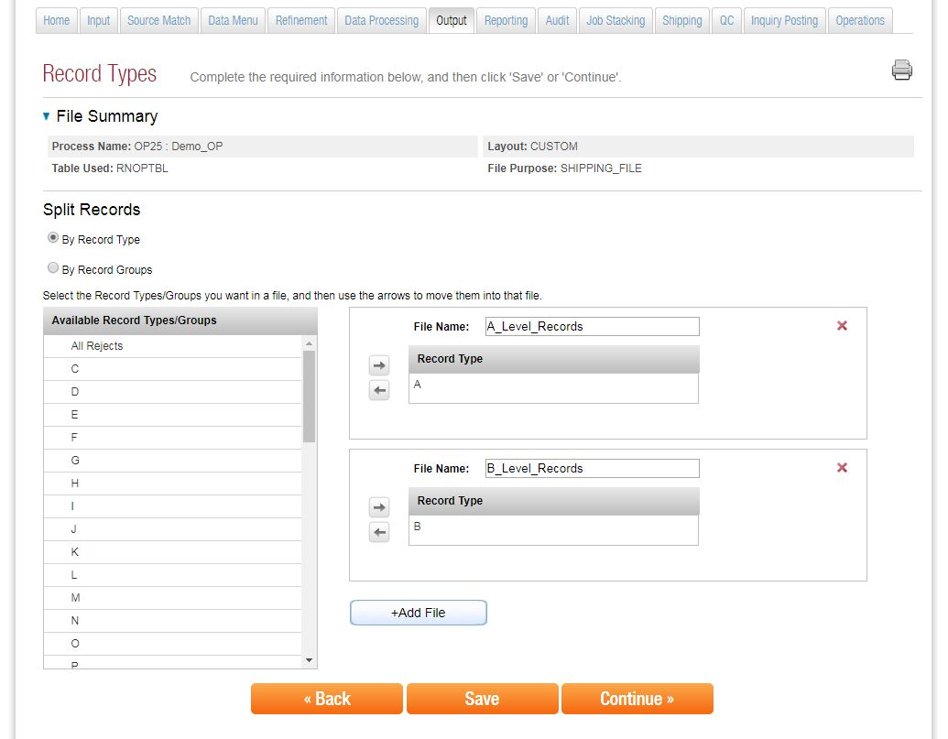

## Split Records

We can create more than one file and designate different types of records to these files. This can be done by either selecting record type or record group.

* **Record Type** – We can specify which type record need to be written in to the given file. For eg A level records to A_Level_Record File and B level records to B_Level_Records file.
* **Record Groups** – Here the file splitting can be done based on the record groups. Eg. Accepts records to Accepts_Records File and Bypassed records to Bypasses_Record File.

## Output Alias

Here we can give alias names for the tables regardless of what we named tables during creation. This means, we can give alias names for already defined logical names for the tables. Only the tables you selected here are going to be expected to be in the Output layout.

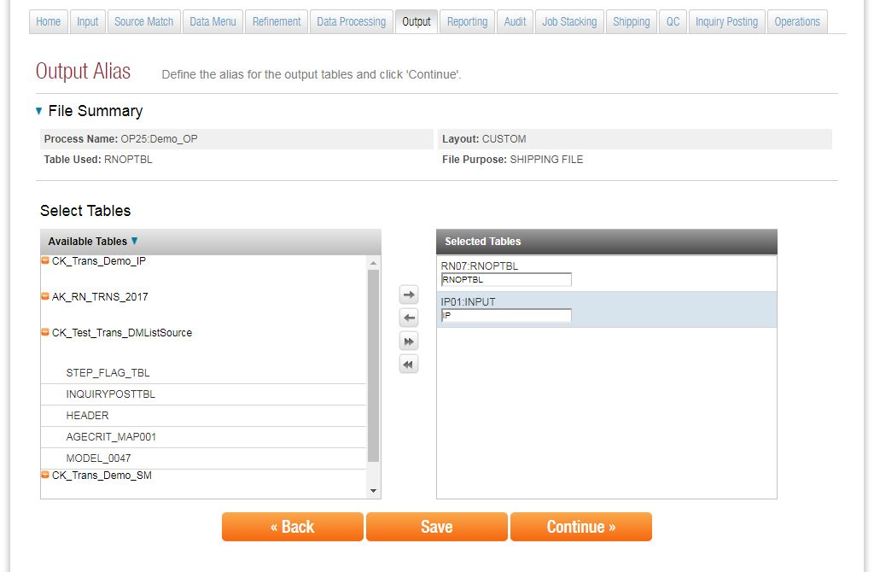

We can add/remove tables to the selected tables list from available tables by using right and left arrows. Once we added a table to the selected tables list, one text box with current name of the table will be displayed. There we can specify the alias name by overwriting the current name of the table if needed.

## Output Configuration

This section defines what should be our out file and how we are going to format it.

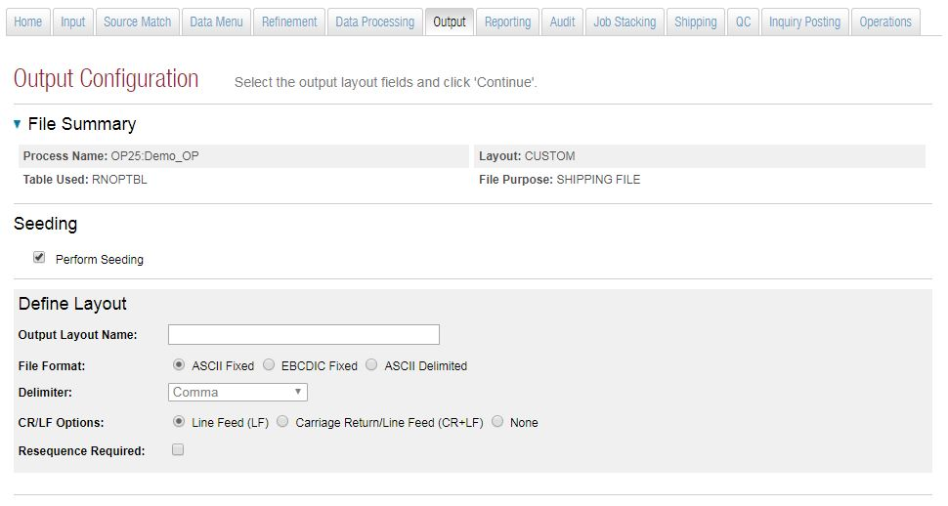

## Seeding

When we send a list to the customer there is contract that they can use the names only once. Seeding helps us to monitor that same names are not using multiple times by the customer. When we seed the records we can get a track of the usage of these records. This is handled by a client service group.

We need PII for enabling the seeding option. If you are trying to write a record that doesn’t have a name and address then it will give a validation error.

## Define Layout

In thissection user need to give the basic details of the layout definitions. This includes:

* **Output Layout Name** – Used to give a name for the output layout
* **File Format** – Defines the format of the output file. Available options are:
* ASCII Fixed
* EBCDIC Fixed
* ASCII Delimited

*If we select the option as ASCII Delimited then it will enables another option to add header records or not*. This will add column name of each fileds.

* **Delimiter** – This will allow the user to specify the delimiter for the output file. Applicable only if we selected ASCII Delimited file format.
* **CR\LF Options**
* **Resequence Required** - For creating sequence number. For eg: In some cases the records have sequence number based on the nodes. If want to change this sequence number we can use resequencing. If we selected this option then it will ask the user to specify the **Starting Number**. This will be used as the starting sequence number. Also this sequence numbers are mapped to a field called **RE_SEQUENCE_NUM**.

## Build the Actual Layout

Here we need to create the actual layout template. That means defining what all things need to be displayed in the output. The left side of the panel will display all the tables that we are selected earlier (Output Alias Step). To build the layout just drag and drop the required fields from the available fields to Selected Layout Fields.

In the Selected Layout Filed we have several options to format the output like changing the data type, Format Fields, Masking etc.

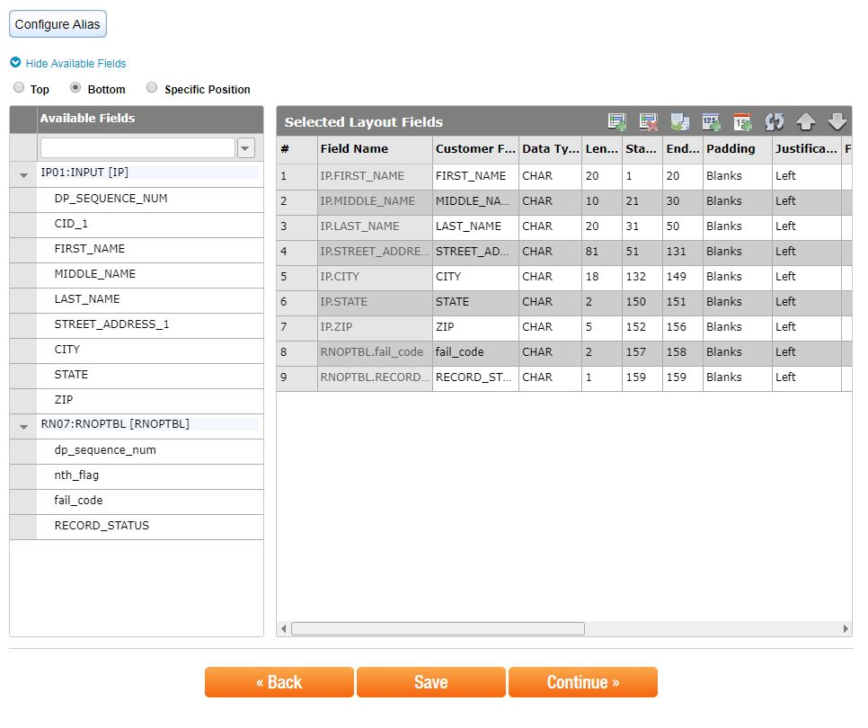

## Configure Alias

This section will provide the user a second chance to configure alias names for the tables and add it to the output layout available Fields section.

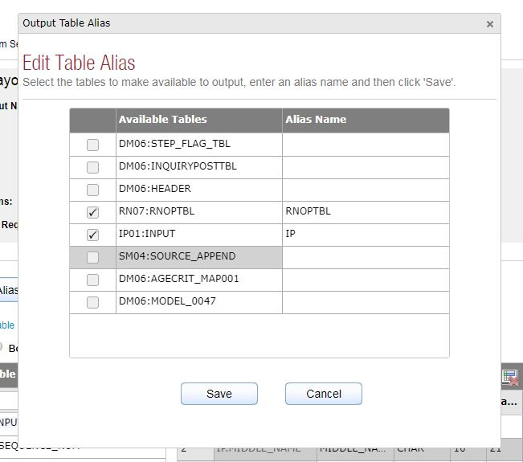

## Output Move Statement

This will allow the user to set the default values for the fields based on record group and type. That means we can use this feature if we don’t want the same value to be written for every record. We can overwrite the value of a particular type of records using output move statement.

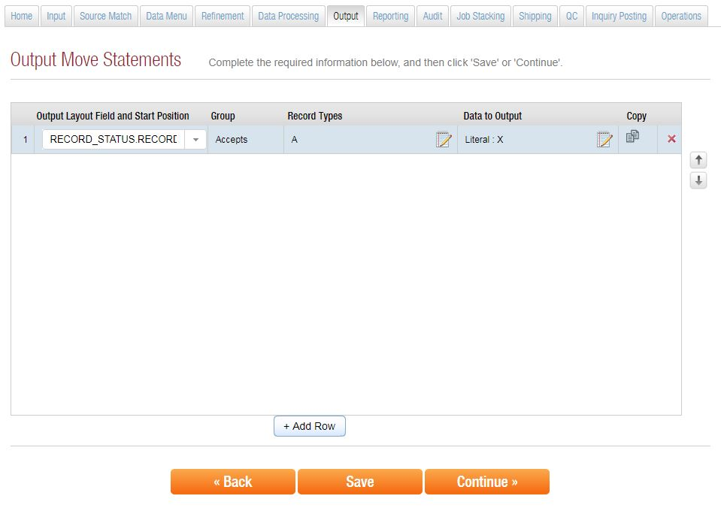

For eg: If we want to overwrite the value of filed RECORD_STATUS with a literal value ‘X’ for all those record which falling in the Record Group – ‘Accepts’ and Record Type – ‘A’; we can use output move statement to configure this.

In this section we need to specify the Filed Name (For which the default value will be applied) , Record Group and Record Type and Data that need to be shown in the output.

We can specify the Record Group and Record Type by clicking the notepad icon under the Record Type field.

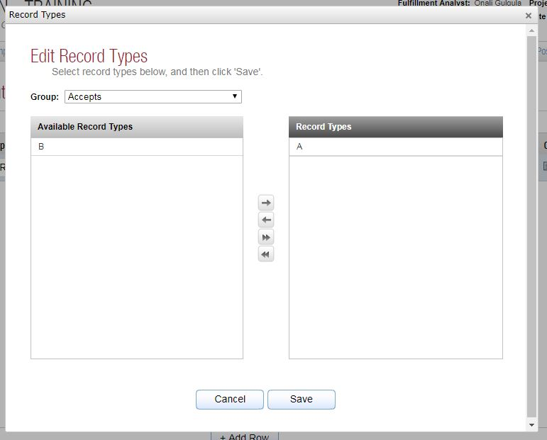

We can specify the Data to be outputted by clicking on the notepad icon under the Data to Output Field. There we can specify Blank Fill, Literal (Specified literal will be used as the default) or Selected Filed (Specified fields value will be used as the default value).

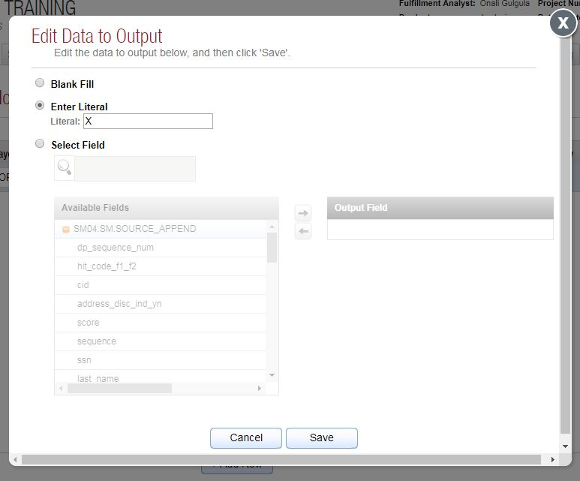

## Sort Order

Here we can mention the sorting order. This can be done by adding the required field for sorting to the sorting fields from available fields and specifying the sorting order (Ascending or Descending). We can add multiple fields also for multi-level sorting.

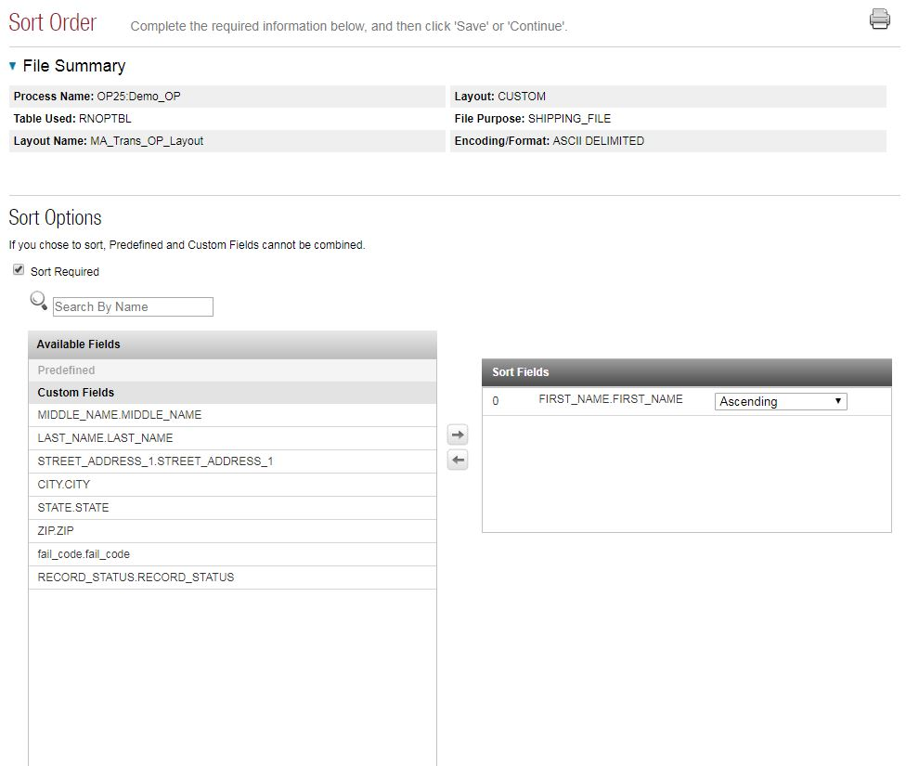

## Output File Naming / Output File Splitting

This section provides the user an option to split the file into multiple files or limit the number of outputs.

## Split the File?

We can use the splitting option if the output file have large amount of data. There are several ways to perform file splitting. The available options are:

* **Split the Output evenly into___ Files** – This will split the Output file into number of output files specified
* **Split the Output into ____ Records per File** – This will creates separate files with the specified number of records
* **Split the Output by _____ Field** – This will split the output file based on the mentioned fields. In this option user is allowed to select a secondary splitting option (option 1 or 2).
* **Split the Output into ____ MB/GB per File** – This will split the output file based on the size(MB or GB).

If selected the option for splitting the file then we need to specify the **Starting File Number** also.

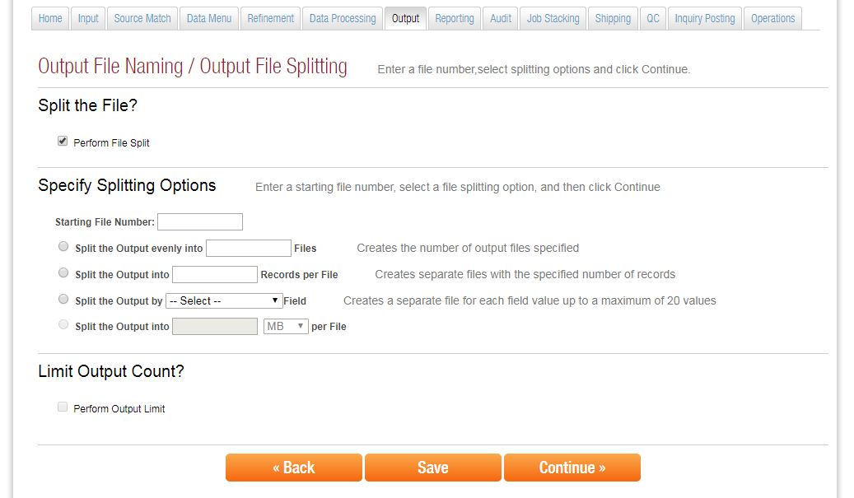

## Limit Output Count?

This option allows the user to limit the number of records in the output file. Like first 1000 records etc. Here we need to mention the maximum number of records to be written in to the file.

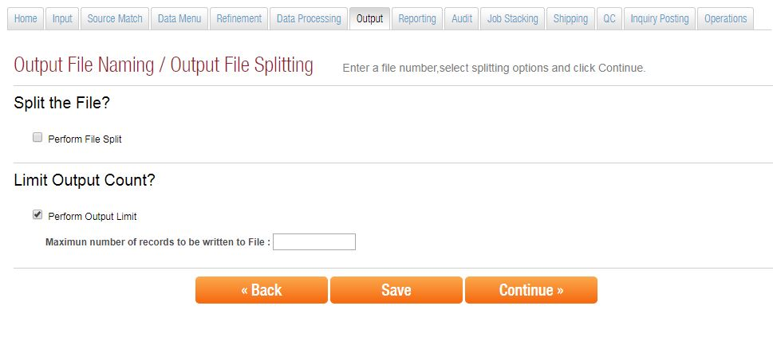

## Data Check

This is similar to the Data Check option under Input process.

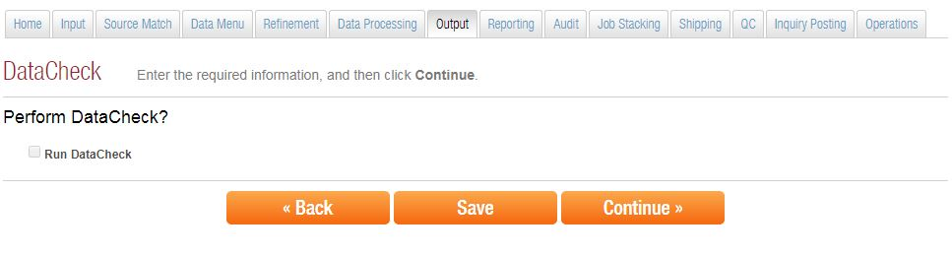

## Summary

This section will display the summary of the output process that we are created.

